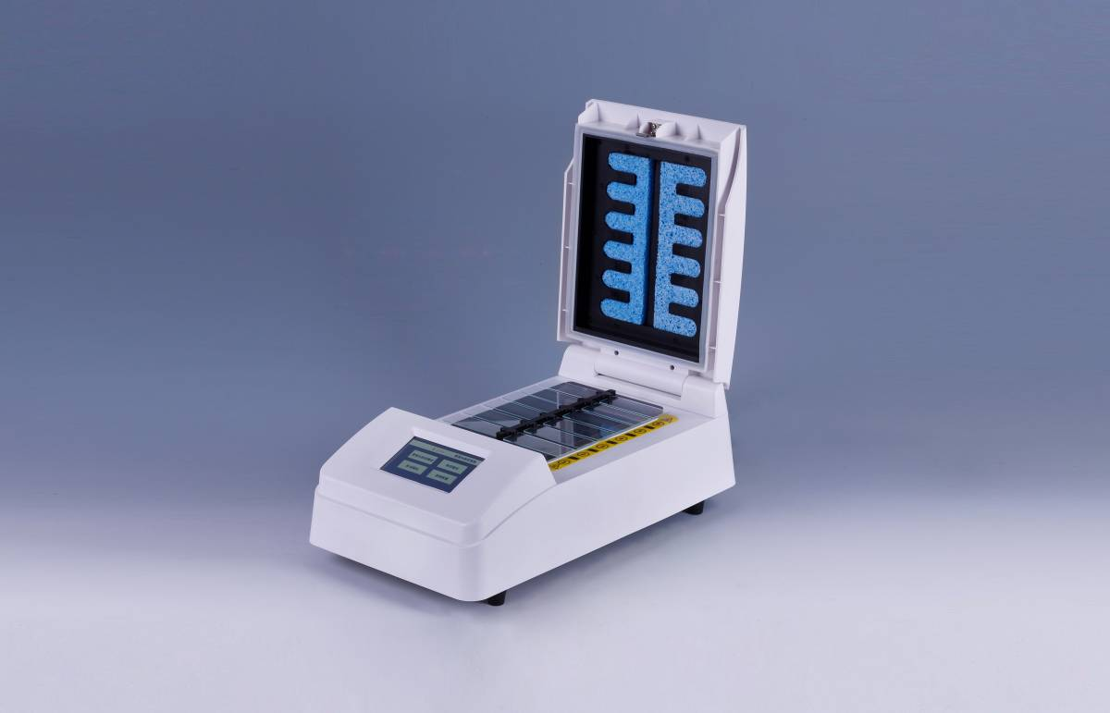
In-situ Hybridization—SH2000

Introduction
SH2000 Hybridization Instrument can be setting constant temperature, time and etc. Instead of manual operation experiment, the accuracy of experiment is higher and result is more reliable than traditional manual experiment. Hybridization and degeneration can be operated at same time, which reduces experimental procedure and improves efficiency and accuracy of operation.

Features:
- This instrument is adopted FISH processing step, which can reduce a lot of manual operating time and avoid the damage of harmful reagent.
- Full touch screen operation, friendly human interface.
- Support restart functionality runs an unexpected power outage, when power is restored can be scheduled to automatically back up and running.
- Supporting automatic cooling function after running over.
- Supporting automatic warm-up function.
- Platform high precision of temperature control, low fluctuation.
- Can deal with 12 slides.
- Support 105 custom programs stored functions.
- Three operation modes: denaturation & hybridization, Hybridization, multiple-step operation.

Parameters
Model | SH2000
Temp. control range | RT+5 ℃ ~100 ℃
Temp. setting range | 0℃~100℃
Time range | 1min ~ 99h59min
Temp. accuracy | ≤ ± 1℃
Uniformity temperature | ≤ ± 1℃
Heating time | ≤2min(from 37℃ to 95℃)
Cooling time | ≤6min(from 95℃ to 45℃)
Capacity | 12Slides
Power | 350W
Input voltage | AC220V or AC110V, 50-60Hz
Fuse | 250V 3A Ф5×20
Dimension(mm) | 440x220x120
Weight(kg) | 4.5

